Sentiment Analysis of E-commerce Product Reviews using Machine Learning and Deep Learning
Name: Ajay Kumar Sahu
Institution: Digicrome Academy, Noida, Uttar Pradesh
Post Graduate Program in Data Science & Artificial Intelligence
Date: 30-05-2026

Introduction
• NLP helps machines understand human language
• Customer reviews contain valuable insights
• Sentiment analysis classifies reviews
• Categories: Positive, Negative, Neutral
Natural Language Processing (NLP) is a branch of Artificial Intelligence that enables machines to understand and process human language. In today’s digital world, customer reviews play a crucial role in decision-making. This project focuses on analyzing customer reviews and classifying them into different sentiment categories such as Positive, Negative, and Neutral.

2. Problem Statement
- Customer reviews are unstructured text data
- Difficulty to manually analyze large volumes of data
- Need an automated system to classify sentiments
- Goal: Identify whether a review is Positive, Negative, and Neutral

Customer reviews are available in large amounts and are in unstructured text format, making difficult to analyze manually. Therefore, there is a need for an automated system that can classify reviews into positive, negative, and neutral sentiments.

3. Objective of the Project
- To perform sentiment analysis on textual data
- To convert unstructured text into structured numerical form
- To build machine learning and deep learning models
- To compare different models and select the best-performing one

The main goal is to classify reviews and compare different models.

4. Dataset Description
The project uses three datasets:
- Train Dataset → Used to train the model (contains sentiment labels)
- Test Dataset → Used for evaluation
- Hidden Dataset → Used for final prediction

Main column used:
- reviews.text → Customer review text
- sentiment → Target variable (Positive, Negative, Neutral)

We used three datasets. Only train data contains sentiment labels.

5. Data Preprocessing
The following preprocessing steps were performed:
- Removal of special characters using regular expressions
- Conversion of text to lowercase
- Removal of stopwords
- Tokenization of text
- Handling of missing values
- Removal of duplicate records

Data cleaning is important to improve model performance.

6. Exploratory Data Analysis (EDA)
EDA was performed to understand the dataset:
- Distribution of sentiment classes
- Word count analysis
- Most frequent words in reviews
- Visualization using count plots and histograms

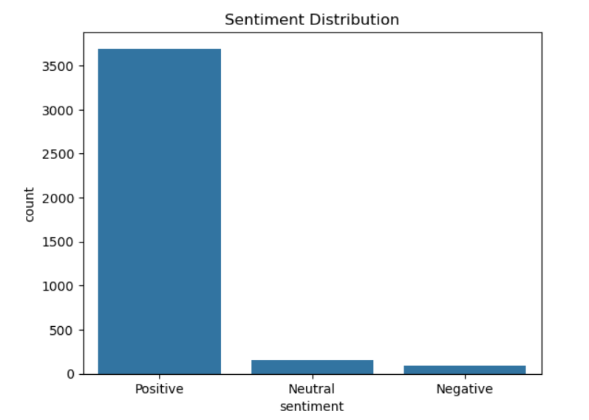
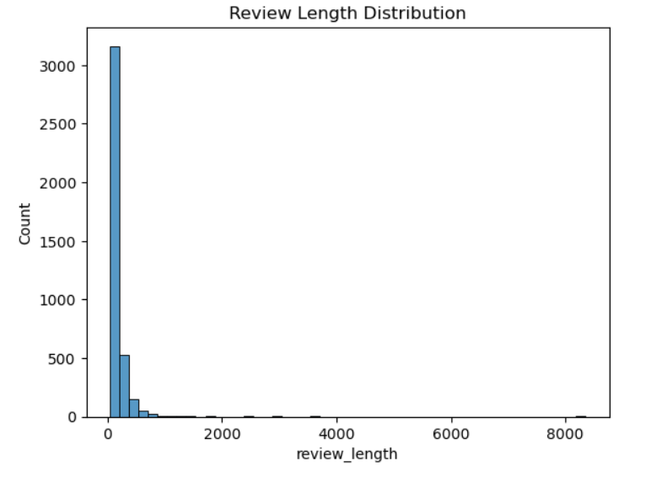
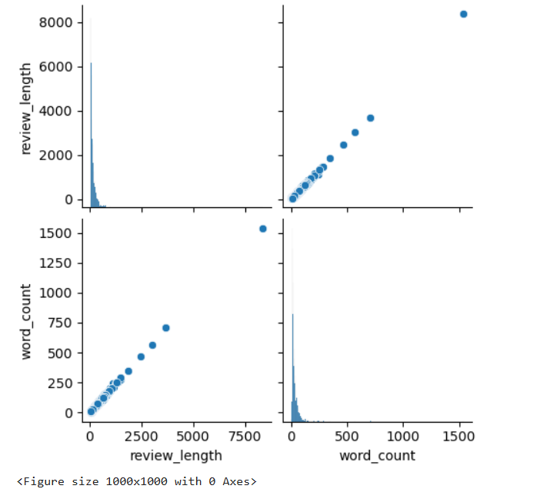

7. Feature Engineering
Text data was converted into numerical form using:
- TF-IDF Vectorization for machine learning models
- Tokenizer and Padding for LSTM model
- Text converted into numerical vector
TF-IDF was fitted on training data and applied to other datasets to maintain consistency.
Machine learning models require numerical data. So, we used TF-IDF and Tokenizer.

8. Handling Imbalanced Data
- Random Over Sampling technique was used
- Balanced the minority classes
- Improved model performance

Oversampling was applied to balance the dataset.

9. Model Building

Machine Learning Models:
- Naive Bayes
- Support Vector Machine (Linear SVM)

Deep Learning Model:
- LSTM (Long Short-Term Memory)

We used both machine learning and deep learning models

LSTM Architecture:
- Embedding Layer
- LSTM Layer (64 units)
- Dropout Layer (0.5)
- Dense Layer with Softmax activation
LSTM captures sequence patterns in text data.

10. Model Evaluation
Models were evaluated using:
- Accuracy
- Confusion Matrix
- Loss and Validation Loss (for LSTM)
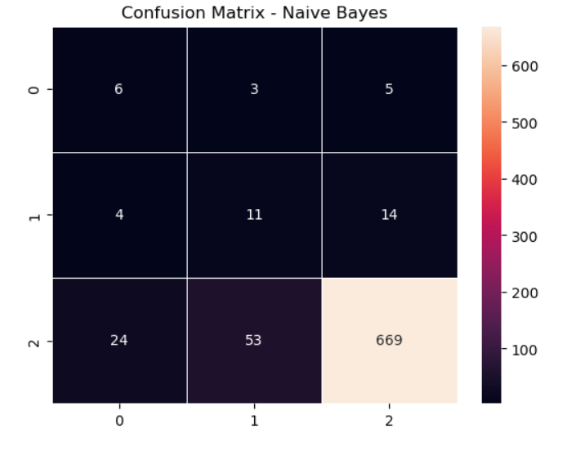
This metrics help evaluate model performance.

11. Best Model Selection
Model | Accuracy
Naïve Bayes | 87%
Linear SVM | 94%
LSTM | 93%

12. Best Model Selection
Among all models, Linear SVM performed best due to:
- High accuracy
- Fast training time
- Better performance on high-dimensional text data

13. Final Prediction
- Most applied on hidden dataset
- Predicted sentiments generated
- Results saved to CSV file
The best model was used to predict sentiment on the hidden dataset.
The results were saved into a CSV file for further analysis.

14. Conclusion
- NLP successfully applied
- Multiple models compared
- Linear SVM performed best
This project successfully implemented sentiment analysis using NLP techniques. Different machine learning and deep learning models were compared, and Linear SVM was found to be the most efficient model for this dataset.

15. Learning Outcomes
- Understanding of NLP pipeline
- Text preprocessing techniques
- Feature extraction using TF-IDF
- Model building and evaluation
- Handling imbalanced data
- Deep learning with LSTM

16. Future Scope
- Use advanced models like BERT
- Improve accuracy with hyperparameter tuning
- Deploy model using web applications

17. References
- Scikit-learn documentation
- TensorFlow/Keras documentation
- NLTK library
- Online tutorials and research papers

Thank You!

